Module5 Activity Paper
1. Preprocessing the Dataset
The dataset was first loaded and explored to understand its structure, data types, categorical values, and missing values. The dataset contains 1,727 observations and seven columns, consisting of six predictor features and one target variable, Class. The initial exploration showed that the features are stored as categorical/object values and that missing values are present in the dataset. Because the goal is to use the data with a linear regression algorithm, the categorical values must first be transformed into numerical values, and the missing values must be handled through imputation.
The preprocessing process included transforming the categorical features into numerical representations and preparing the target variable for regression. After transformation, four imputation approaches were evaluated to replace missing values: zero imputation using SimpleImputer(strategy="constant",fill_value=0), mean imputation using SimpleImputer(strategy="mean"), KNN imputation using KNNImputer(), and iterative imputation using IterativeImputer(). Each imputation method was incorporated into the modeling process using a Scikit-Learn pipeline. Four-fold cross-validation with cross_val_score() and negative mean squared error was then used to evaluate and compare the model performance. The starter code specifically requires these four imputation approaches to be evaluated.
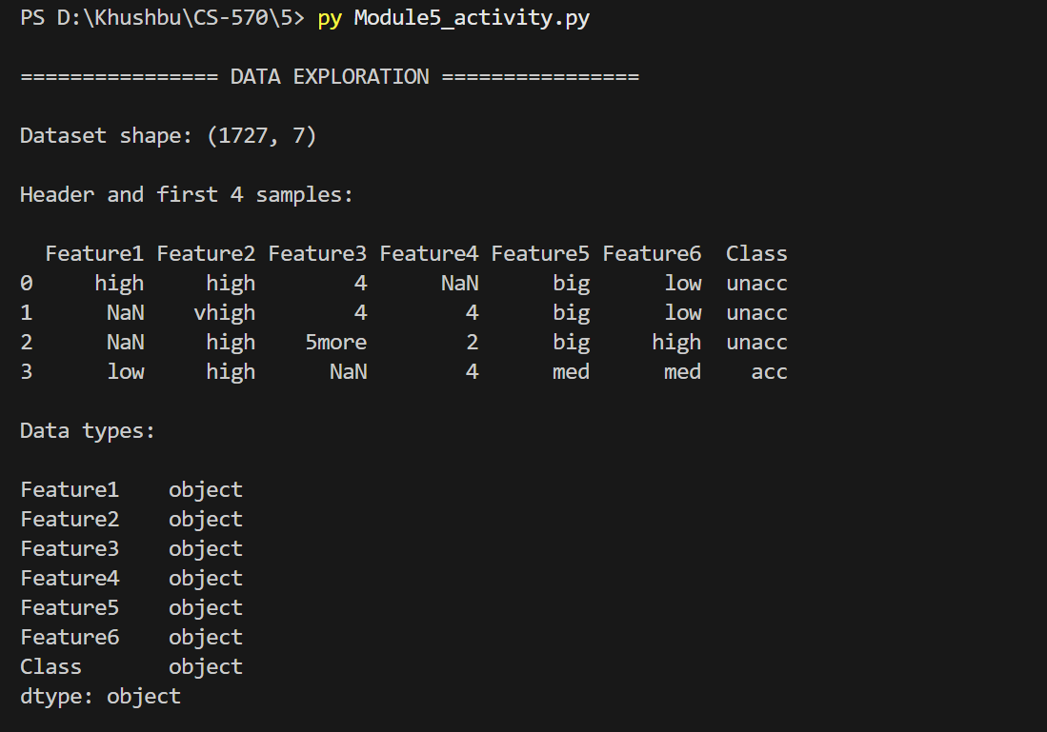
Figure 1. Dataset shape, header, first four samples, and data types.
2) Summarize the Dataset
a) How many features does the dataset contain?
The dataset contains six predictor features: Feature1, Feature2, Feature3, Feature4, Feature5, and Feature6. The dataset also contains one target variable, Class, which represents the class to be predicted. Therefore, there are six input features and one target variable, for a total of seven columns in the dataset.
b) How many samples does the data set contain?
The dataset contains 1,727 samples. Each sample represents one observation containing values for the six predictor features and the corresponding Class value. The dataset shape of (1727, 7) confirms that there are 1,727 observations and seven columns.
c) What are the unique values for each feature and class?
The unique values for each predictor feature and the target class were identified during the data exploration process. Feature1 and Feature2 contain the categories low, med, high, and vhigh. Feature3 contains 2, 3, 4, and 5more. Feature4 contains 2, 4, and more. Feature5 contains small, med, and big, while Feature6 contains low, med, and high. The target variable Class contains four categories: unacc, acc, good, and vgood.
Variable | Unique Values
Feature1 | low, med, high, vhigh
Feature2 | low, med, high, vhigh
Feature3 | 2, 3, 4, 5more
Feature4 | 2, 4, more
Feature5 | small, med, big
Feature6 | low, med, high
Class | unacc, acc, good, vgood

The dataset also contains missing values in the predictor features. The number of non-missing observations varies among the features, while the Class variable contains values for all 1,727 samples. Identifying these categorical values and missing observations is important because the original data cannot be directly supplied to the linear regression algorithm.
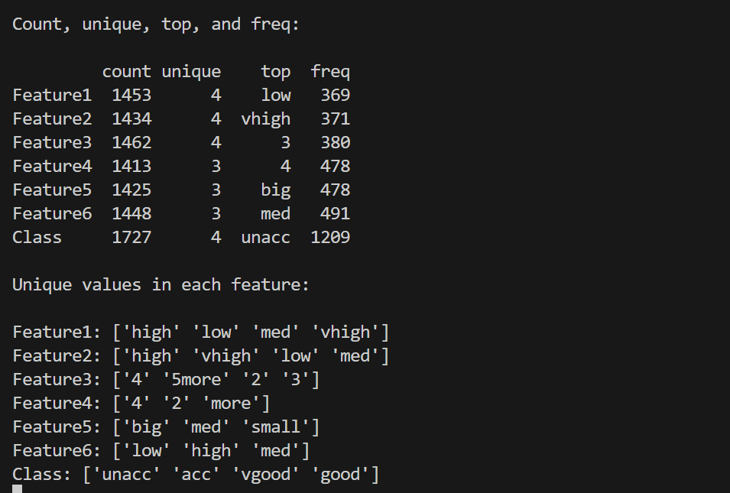
Figure 2. Summary of the dataset showing count, unique values, most frequent values, and their frequencies.
3) Generate a Correlation Matrix
a) Did you have to transform the dataset to generate the correlation matrix?
Yes, the dataset had to be transformed before generating the correlation matrix. The original dataset contains categorical values stored as text, so the variables could not be directly used to calculate numerical correlations. The predictor features were therefore converted into numerical values using ordinal encoding while preserving the natural ordering of their categories. The Class variable was also encoded numerically. After this transformation, the resulting numerical dataset was used to generate the correlation matrix.
The transformation was necessary because correlation analysis requires numerical values. The encoded correlation matrix allowed the relationships among the features and the target variable to be examined. The results showed that some features had stronger relationships with the target than others, providing useful information about the structure of the dataset before applying the imputation techniques.
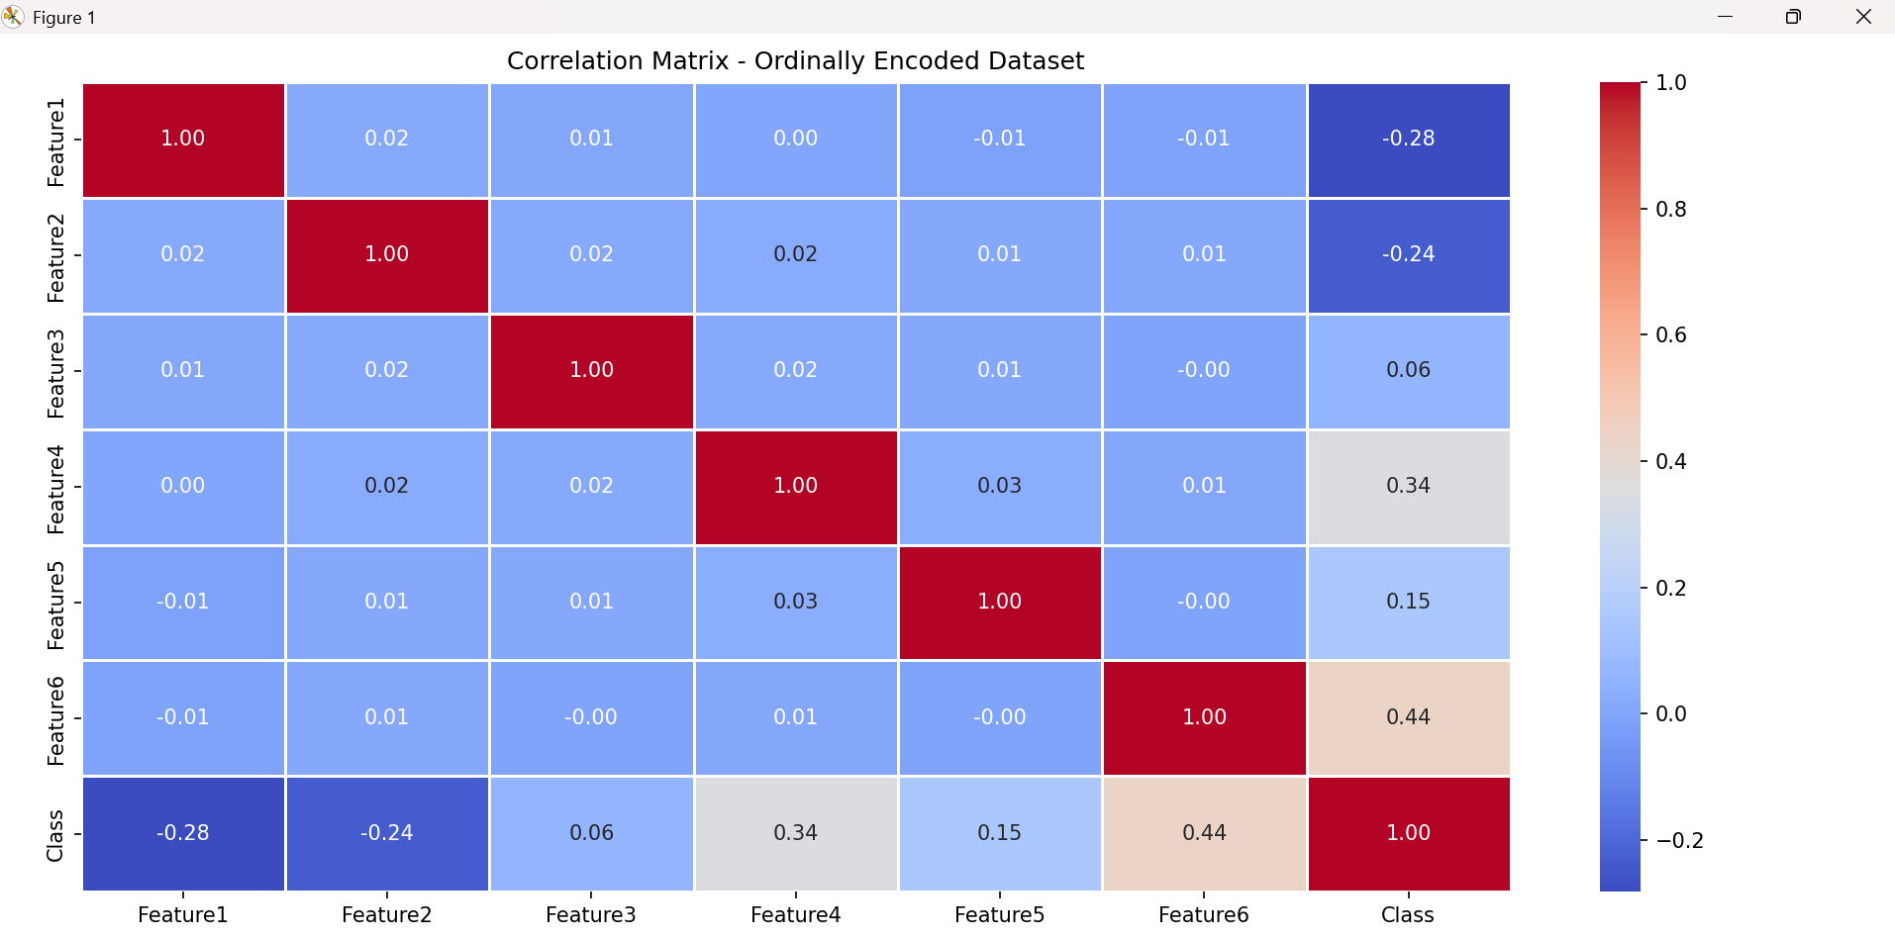
Figure 3. Correlation matrix of the ordinally encoded dataset.
4) Score the Model Before Imputation
Before applying any imputation technique, the transformed dataset was evaluated using a linear regression model with four-fold cross-validation. However, a valid pre-imputation model score could not be obtained because the ordinally encoded dataset still contained missing (NaN) values. Although the categorical variables had been converted into numerical values, LinearRegression cannot train when predictor variables contain NaN values. Therefore, the raw dataset was not assigned a numerical cross-validation score, rather than reporting an invalid result. This is consistent with the provided Python implementation, which catches the resulting error and reports the raw dataset score as unavailable.
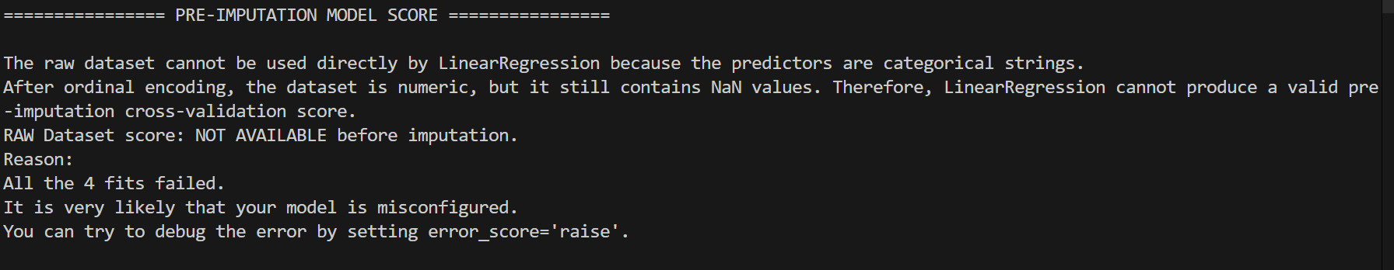
Figure 4. Pre-imputation model score showing that a valid cross-validation score could not be obtained because the dataset contains missing values.
5) Explain how you preprocessed the provided data set to fit a linear regression algorithm.
a) What data types are required for the linear regression algorithm?
Linear regression requires the predictor variables to be numerical data and the target variable to be numerical. The original dataset contained categorical features represented as strings, so the raw categorical data could not be directly used by the LinearRegression algorithm. The dataset also contained missing values (NaN) that prevented the regression model from fitting successfully. Therefore, the categorical variables needed to be transformed into numerical values and the missing predictor values needed to be handled before applying linear regression.
b) Which data transforming processes, if any, did you use and why?
Ordinal encoding was used to transform the categorical features into numerical values. The six predictor features contained ordered categories, so ordinal encoding was appropriate because it represents the categories numerically while preserving their underlying order. The Class target variable was also encoded numerically so that it could be used as the regression target. Missing values were intentionally preserved during the encoding stage and were handled separately using the required imputation techniques.
c) What factors did you use to decide how to preprocess the data?
i) How did the algorithm type inform the preprocessing techniques?
The choice of preprocessing was primarily determined by the requirements of linear regression. Linear regression cannot directly process categorical strings, so the categorical predictor variables had to be converted to numerical values. In addition, linear regression cannot accept NaN values in its predictors. Therefore, both ordinal encoding and missing-value imputation were necessary before the model could be trained.
ii) What data characteristics did you consider for preprocessing?
The main data characteristics considered were the categorical nature of the predictor variables, their ordered categories, and the presence of missing values. Feature1 through Feature6 contained categorical values with meaningful ordering. For example, Feature5 contained small, med, and big, while Feature6 contained low, med, and high. Because these categories have an inherent order, ordinal encoding was selected. The dataset also contained substantial missing values, which required imputation.
iii) How did other factors such as algorithmic constraints affect preprocessing?
Algorithmic constraints had a direct effect on the preprocessing decisions. LinearRegression requires numerical predictors and does not accept missing values. Consequently, categorical strings had to be converted into numerical representations before modeling, and the missing values had to be replaced through imputation. The assignment also required comparison of constant-zero, mean, KNN, and iterative imputation using four-fold cross-validation, so these requirements were incorporated into the preprocessing and model evaluation process.
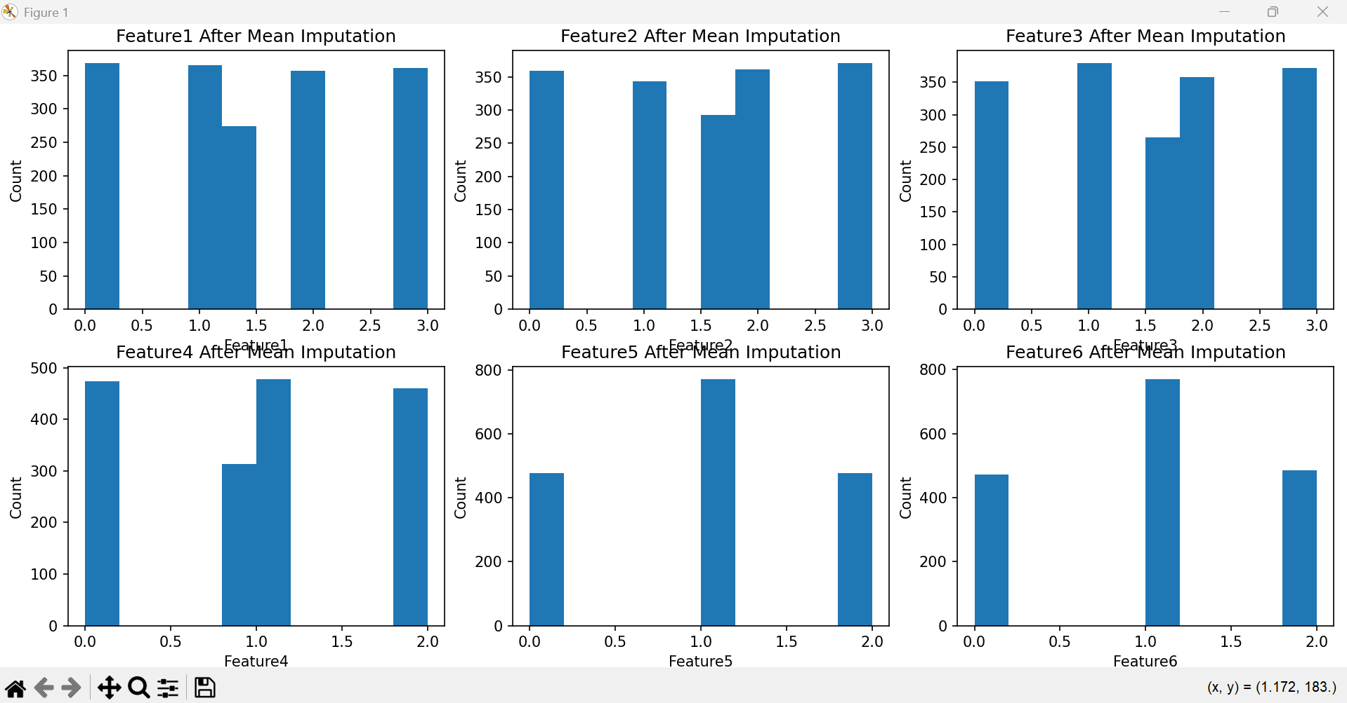
Figure 5. Distribution of the six predictor features after mean imputation.
6) Compare the scores of the different imputer algorithms
Four imputation methods were evaluated using four-fold cross-validation with negative mean squared error (MSE) as the scoring metric. Since scikit-learn reports negative MSE, a score closer to zero indicates better model performance. The four methods evaluated were zero imputation, mean imputation, KNN imputation, and iterative imputation.
 | Negative MSE | STD
  Imputation Method
Zero Imputation | -0.391528 | 0.070897
Mean Imputation | -0.342068 | 0.047694
KNN Imputation | -0.357381 | 0.051949
Iterative Imputation | -0.342077 | 0.047685
Mean imputation produced the best cross-validation result, with a negative MSE of -0.342068, because it was the value closest to zero. Iterative imputation produced a nearly identical result of -0.342077, but was marginally worse. KNN imputation produced -0.357381, while zero imputation produced the least favorable result at -0.391528. Therefore, mean imputation was the best-performing imputation method for this dataset and linear regression model.
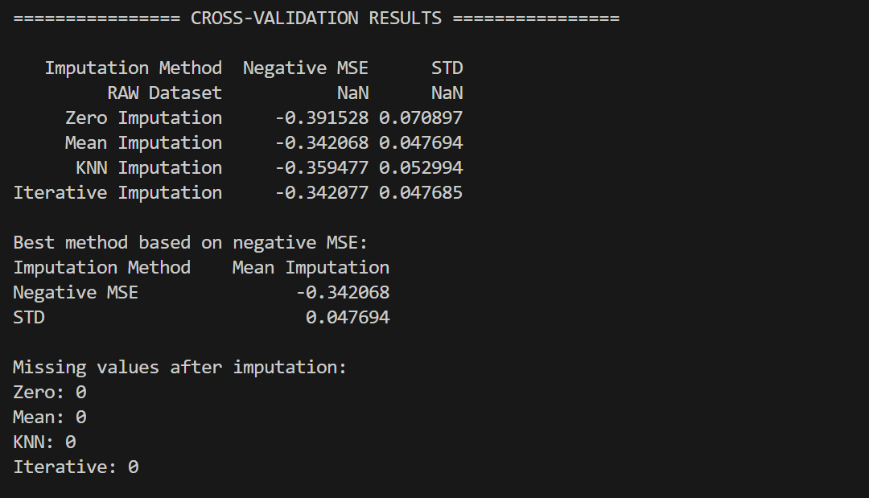
Figure 6. Data visualizations after mean imputation.
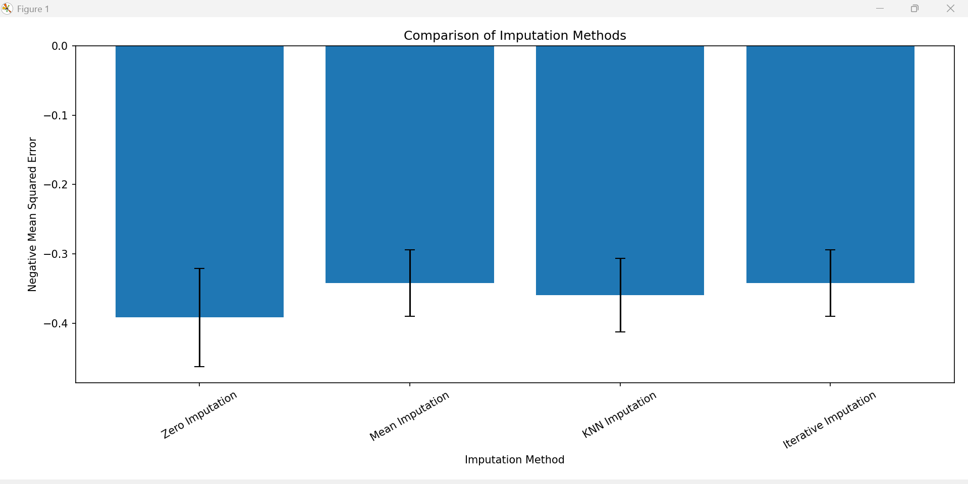
Figure 7. Comparison of cross-validation scores for the imputation methods.
Conclusion
This project demonstrated the importance of preprocessing incomplete categorical data before applying a linear regression model. The dataset contained six categorical predictor features and missing values, so the features were transformed into numerical ordinal values and the missing values were handled using multiple imputation techniques. Four imputation methods—zero, mean, KNN, and iterative imputation—were evaluated using four-fold cross-validation. Among the tested methods, mean imputation produced the best negative MSE, with iterative imputation performing nearly identically. The results show that appropriate preprocessing and imputation are necessary to make the dataset suitable for linear regression and can affect the resulting model performance.
References
Scikit-learn developers. (n.d.). LinearRegression. Scikit-learn. https://scikit-learn.org/stable/modules/generated/sklearn.linear_model.LinearRegression.html
Scikit-learn developers. (n.d.). SimpleImputer. Scikit-learn. https://scikit-learn.org/stable/modules/generated/sklearn.impute.SimpleImputer.html
Scikit-learn developers. (n.d.). KNNImputer. Scikit-learn. https://scikit-learn.org/stable/modules/generated/sklearn.impute.KNNImputer.html
Scikit-learn developers. (n.d.). IterativeImputer. Scikit-learn. https://scikit-learn.org/stable/modules/generated/sklearn.impute.IterativeImputer.html
Scikit-learn developers. (n.d.). cross_val_score. Scikit-learn. https://scikit-learn.org/stable/modules/generated/sklearn.model_selection.cross_val_score.html

